HubPages
- sign in
- start a new hub
- my account
- join
- help
- browse »
- Topics
- Hubs
- Answers
- Hubbers
- Forums
- Feed



- All Topics
- Technology
- Computers and Software
- Computer Science and Programming
- Code Samples

- Types of Function in C Programming Languages:

Types of Function in C Programming Languages:
78
rate or flag this pageTweet this
By rajkishor09
In my previous c programming tutorial I tried to explain what the function, its advantages is and how to declare a C function. And I told you that there are five types of functions and they are:
- Functions with no arguments and no return values.
- Functions with arguments and no return values.
- Functions with arguments and return values.
- Functions that return multiple values.
- Functions with no arguments and return values.

C Programming Language
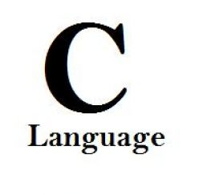
Free C programming tutorials for all beginners.

1. Functions with no arguments and no return value.
A C function without any arguments means you cannot pass data (values like int, char etc) to the called function. Similarly, function with no return type does not pass back data to the calling function. It is one of the simplest types of function in C. This type of function which does not return any value cannot be used in an expression it can be used only as independent statement. Let’s have an example to illustrate this.
- #include<stdio.h>
- #include<conio.h>
- void printline()
- {
- int i;
- printf("\n");
- for(i=0;i<30;i++)
- {
- printf("-");
- }
- printf("\n");
- }
- void main()
- {
- clrscr();
- printf("Welcome to function in C");
- printline();
- printf("Function easy to learn.");
- printline();
- getch();
- }
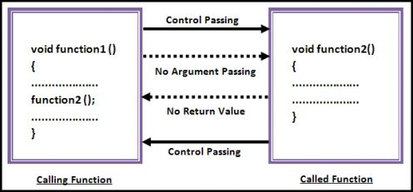

See all 9 photos

Logic of the functions with no arguments and no return value.

Output
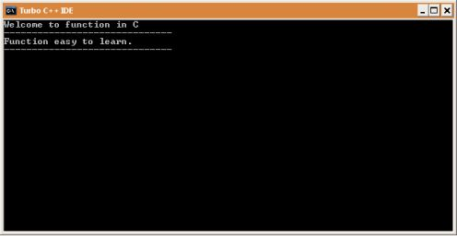
Output of above program.

Source Code Explanation:
The above C program example illustrates that how to declare a function with no argument and no return type. I am going to explain only important lines only because this C program example is for those who are above the beginner level.
Line 3-12: This C code block is a user defined function (UDF) whose task is to print a horizontal line. This is a simple function and a basic programmer can understand this. As you can see in line no. 7 I have declared a “for loop” which loops 30 time and prints “-” symbol continuously.
Line 13-21: These line are “main()” function code block. Line no. 16 and 18 simply prints two different messages. And line no. 17 and 18 calls our user defined function “printline()”. You can see output this program below

C Language Books
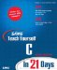 | Sams Teach Yourself C in 21 Days (6th Edition)  Amazon Price: $25.00  List Price: $49.99
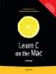 | Learn C on the Mac (Learn Series)  Amazon Price: $20.15  List Price: $39.99
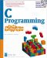 | C Programming for the Absolute Beginner (For the Absolute Beginner (Series).)  Amazon Price: $53.00  List Price: $29.99
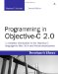 | Programming in Objective-C 2.0 (2nd Edition)  Amazon Price: $25.99  List Price: $44.99

2. Functions with arguments and no return value.
In our previous example what we have noticed that “main()” function has no control over the UDF “printfline()”, it cannot control its output. Whenever “main()” calls “printline()”, it simply prints line every time. So the result remains the same.
A C function with arguments can perform much better than previous function type. This type of function can accept data from calling function. In other words, you send data to the called function from calling function but you cannot send result data back to the calling function. Rather, it displays the result on the terminal. But we can control the output of function by providing various values as arguments. Let’s have an example to get it better.
- #include<stdio.h>
- #include<conio.h>
- void add(int x, int y)
- {
- int result;
- result = x+y;
- printf("Sum of %d and %d is %d.\n\n",x,y,result);
- }
- void main()
- {
- clrscr();
- add(30,15);
- add(63,49);
- add(952,321);
- getch();
- }
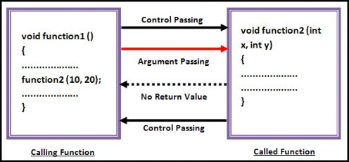
Logic of the function with arguments and no return value.

Output
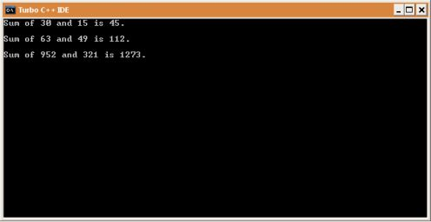
Output of above program.

Source Code Explanation:
This program simply sends two integer arguments to the UDF “add()” which, further, calculates its sum and stores in another variable and then prints that value. So simple program to understand.
Line 3-8: This C code block is “add()” which accepts two integer type arguments. This UDF also has a integer variable “result” which stores the sum of values passed by calling function (in this example “main()”). And line no. 7 simply prints the result along with argument variable values.
Line 9-16: This code block is a “main()” function but only line no. 12, 13, 14 is important for us now. In these three lines we have called same function “add()” three times but with different values and each function call gives different output. So, you can see, we can control function’s output by providing different integer parameters which was not possible in function type 1. This is the difference between “function with no argument” and “function with argument”.

Bestselling Books
 | The 5000 Year Leap (Original Authorized Edition)  Amazon Price: $10.89  List Price: $19.95
 | Hungry Girl: 200 Under 200: 200 Recipes Under 200 Calories  Amazon Price: $9.30  List Price: $19.95
 | Cook Yourself Thin: Skinny Meals You Can Make in Minutes  Amazon Price: $0.95  List Price: $19.99
 | Act Like a Lady, Think Like a Man: What Men Really Think About Love, Relationships, Intimacy, and Commitment  Amazon Price: $8.99  List Price: $23.99

3. Functions with arguments and return value.
This type of function can send arguments (data) from the calling function to the called function and wait for the result to be returned back from the called function back to the calling function. And this type of function is mostly used in programming world because it can do two way communications; it can accept data as arguments as well as can send back data as return value. The data returned by the function can be used later in our program for further calculations.
- #include<stdio.h>
- #include<conio.h>
- int add(int x, int y)
- {
- int result;
- result = x+y;
- return(result);
- }
- void main()
- {
- int z;
- clrscr();
- z = add(952,321);
- printf("Result %d.\n\n",add(30,55));
- printf("Result %d.\n\n",z);
- getch();
- }
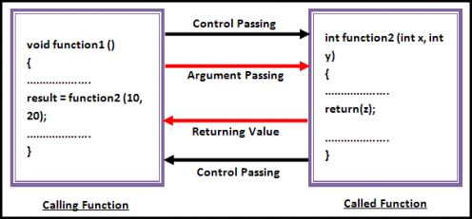
Logic of the function with arguments and return value.
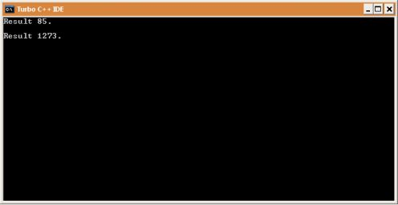
Output of the above program.

Source Code Explanation:
This program sends two integer values (x and y) to the UDF “add()”, “add()” function adds these two values and sends back the result to the calling function (in this program to “main()” function). Later result is printed on the terminal.
Line No. 3-8: Look line no. 3 carefully, it starts with int. This int is the return type of the function, means it can only return integer type data to the calling function. If you want any function to return character values then you must change this to char type. On line no. 7 you can see return statement, return is a keyword and in bracket we can give values which we want to return. You can assign any integer value to experiment with this return which ultimately will change its output. Do experiment with all you program and don’t hesitate.
Line No. 9-17: In this code block only line no. 13, 14 and 15 is important. We have declared an integer “z” which we used in line no. 13. Why we are using integer variable “z” here? You know that our UDF “add()” returns an integer value on calling. To store that value we have declared an integer value. We have passed 952, 321 to the “add()” function, which finally return 1273 as result. This value will be stored in “z” integer variable. Now we can use “z” to print its value or to other function.
You will also notice some strange statement in line no. 14. Actually line no. 14 and 15 does the same job, in line no. 15 we have used an extra variable whereas on line no. 14 we directly printed the value without using any extra variable. This was simply to show you how we can use function in different ways.

4. Functions with no arguments but returns value.
We may need a function which does not take any argument but only returns values to the calling function then this type of function is useful. The best example of this type of function is “getchar()” library function which is declared in the header file “stdio.h”. We can declare a similar library function of own. Take a look.
- #include<stdio.h>
- #include<conio.h>
- int send()
- {
- int no1;
- printf("Enter a no : ");
- scanf("%d",&no1);
- return(no1);
- }
- void main()
- {
- int z;
- clrscr();
- z = send();
- printf("\nYou entered : %d.", z);
- getch();
- }

Functions with no arguments and return values.
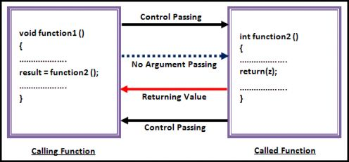
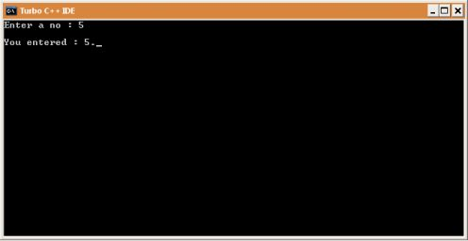
Output of the above program.

Bestselling of Music
 | Something To Say  Amazon Price: $8.99
 | Number 1's  Amazon Price: $9.49
 | Boom Boom Pow  Amazon Price:
 | My Paper Heart  Amazon Price: $5.99

Bestselling Games
 | Left 4 Dead  Amazon Price: $14.90  List Price: $19.99
 | World of Warcraft: Wrath of the Lich King Expansion Pack  Amazon Price: $29.99  List Price: $39.99
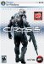 | Crysis Collector's Edition  Amazon Price: $35.00  List Price: $49.99
 | Crysis Maximum Edition  Amazon Price: $33.29  List Price: $39.99

Source Code Explanation:
In this program we have a UDF which takes one integer as input from keyboard and sends back to the calling function. This is a very easy code to understand if you have followed all above code explanation. So I am not going to explain this code. But if you find difficulty please post your problem and I will solve that.

5. Functions that return multiple values.
So far, we have learned and seen that in a function, return statement was able to return only single value. That is because; a return statement can return only one value. But if we want to send back more than one value then how we could do this?
We have used arguments to send values to the called function, in the same way we can also use arguments to send back information to the calling function. The arguments that are used to send back data are called Output Parameters.
It is a bit difficult for novice because this type of function uses pointer. Let’s see an example:
- #include<stdio.h>
- #include<conio.h>
- void calc(int x, int y, int *add, int *sub)
- {
- *add = x+y;
- *sub = x-y;
- }
- void main()
- {
- int a=20, b=11, p,q;
- clrscr();
- calc(a,b,&p,&q);
- printf("Sum = %d, Sub = %d",p,q);
- getch();
- }
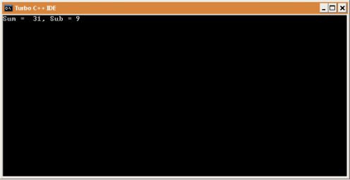
Output of the above program.

Source Code Explanation:
Logic of this program is that we call UDF “calc()” and sends argument then it adds and subtract that two values and store that values in their respective pointers. The “*” is known as indirection operator whereas “&” known as address operator. We can get memory address of any variable by simply placing “&” before variable name. In the same way we get value stored at specific memory location by using “*” just before memory address. These things are a bit confusing but when you will understand pointer then these thing will become clearer.
Line no. 3-7: This UDF function is different from all above UDF because it implements pointer. I know line no. 3 looks something strange, let’s have a clear idea of it. “Calc()” function has four arguments, first two arguments need no explanation. Last two arguments are integer pointer which works as output parameters (arguments). Pointer can only store address of the value rather than value but when we add * to pointer variable then we can store value at that address.
Line no. 8-15: When we call “calc()” function in the line no. 12 then following assignments occurs. Value of variable “a” is assigned to “x”, value of variable “b” is assigned to “y”, address of “p” and “q” to “add” and “sub” respectively. In line no. 5 and 6 we are adding and subtracting values and storing the result at their respective memory location. This is how the program works.
I tried to put things in simple for beginner but if you find it difficult to understand then please let me know through comments and I will try to change that part as soon as possible.

Bestselling iPods
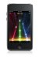 | Apple iPod touch 16 GB (2nd Generation) [Previous Model]  Amazon Price: $325.00  List Price: $279.99
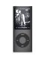 | Apple iPod nano 8 GB Black (4th Generation) [Previous Model]  Amazon Price: $229.99  List Price: $129.99
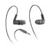 | Altec Lansing UHP336 Snugfit In-ear Earphone  Amazon Price: $39.99  List Price: $129.95

Help me to write better.

Did this help you?

-  Yes
- No
- Can't Say

See results without voting

More Article
- How to get a 100% free website?
Before making this decision I feel that we should aware about some basic terms which are frequently used in internet world. Domain name: First of all what we ponder when we think about a website is the...
- How to work from home on internet
How to make money online? This is the common and highest searched term on internet. You will also get numerous answers to this query. But, before following any answer, please make sure which type of money...
- How to build ultimate and extreme gaming computers?
- File Copy Program in C Language
Today we are going to learn a simple file copy program in C language. As I said this is a simple file copy program so you should not expect its output like DOS copy command has. Ok lets start. The main...
- A Brief History of the C Language
Before we start any complex program in C, we must understand what really C is, how it came into existence and how it differs from other languages of that time. In this tutorial I will try to talk about these...
- Turn Your PC Keyboard to Musical Keyboard
To accomplish this task you dont need to buy any expensive software or hardware, only a little knowledge of C program will do and you can build your own musical keyboard software. Before we begin you...
VOTE UPVOTE DOWNSHAREPRINTFLAG
Was this Hub ...?
- useful (7)
- funny (1)
- awesome (4)
- beautiful (1)
Programming in C: What is Function in C Language?
Programming in C: Turn Your PC Keyboard to Musical Keyboard using C Program
Comments
latha 16 months ago
You clearly explained about function calls. Thanks a lot. if possible Please post topics on data structures in c also.
cheryl 16 months ago
please give more example
narasimha 15 months ago
i got the required information.thank u
Guri 14 months ago
I really very happy when i see most of us information was there
thanks
Vaibhav P 13 months ago
really explained each and every type clearly thanks a lot it was really very useful
ANA 12 months ago
i get satisfactory information, which i want. really thanks.
bromanz 12 months ago
thnx man you really help me
garvit 12 months ago
grt work man..........
monika 9 months ago
excellent way to give a propre defintions on c language associated functions
minakshi 8 months ago
great..........
padmavathy s 8 months ago
give example for multiple values with out using pointer variable

techno geek 8 months ago
hi really nice hub.............do u have source code for parser..............
Deepa 7 months ago
hey!!! really awesome explanation..i was confused about functions before entering in to this site..thanks alot..
Jeff AmA 7 months ago
got the right staff sport on. Kudos
dhanam 7 months ago
what a excellent explanation....its very useful to improve my knowledge.....thank u boss
jopy 7 months ago
thankzx a lot
sluxtpr 6 months ago
really super explanation

save my system 6 months ago
Hey you explain very clearly and effectively about function. Function keeps main importance in C language. I simplifies program a lot.

Manna in the wild 6 months ago
C rocks. Just got to keep those pointers under control!
DANYAL(PAKI) 6 months ago
GREAT JOB....KEEP IT UP...
bharani 6 months ago
it is very easy to understand informations abouy c thnx a lot
kashif 5 months ago
easy to understand
kim magtoto 5 months ago
nice
chin 4 months ago
wow.. its so easy to understand.. how to program :)
chandan 4 months ago
very good
neeraja 3 months ago
It is very useful to us.Thank you very much
marky 3 months ago
does the gantt chart exist in this language?
nbbatt.com 3 months ago
Thanks for your explanation. it helps me to understand it.
saurabh 3 months ago
btr dn a text book :)
shobin 2 months ago
thanks
Swarnalata 2 months ago
Functions are explained clearly and with simple examples.
It helps in better understanding. Thanks.
negative 2 months ago
can u give more examples???
Ranjani 2 months ago
Thanks for clear explanation
annapoorani ct 2 months ago
thanks for ur clear explanation
syed abthahir 2 months ago
please,clear explanation in functions of c program
Anil 7 weeks ago
thank u i got the information
joseph 6 weeks ago
my problem is using switch functions, im counting the days between the entering the first month and last month
example
suppose im enter 2 in the first month
and 5 for the last month the solution must be
28+31+30+31+30
the output must be 120 and asking again the program if he/her try again
anita kapil 5 weeks ago
iam totally confused
shree 5 weeks ago
example programs and explanation was very clear and easy to understand
SkyKing 5 weeks ago
well done.. thanks a lot.. finally, I can answer my homework! ^^
Princess 5 weeks ago
I really dont understand the function
shobin 4 weeks ago
In Fn. with arguments and no return type,how we take run time entries.

rajkishor09 4 weeks ago
@shobin i think u want to take input from user, if so then u can use scanf within function as u do in main().
gourav 3 weeks ago
thanks dude
shobin 2 weeks ago
if we use scanf in function then it is fn.with arguments.
shobin 2 weeks ago
please explain this clearly;
shobin 2 weeks ago
#include
#include
void add(int x, int y)
{
int result;
result = x+y;
printf("Sum of %d and %d is %d.\n\n",x,y,result);
}
void main()
{
clrscr();
add(30,15);
add(63,49);
add(952,321);
getch();
}
sir,please tell this is right or wrong.
shobin 2 weeks ago
void add(int b,int c)
{
int a;
a=b+c;
cout
rajkishor09 2 weeks ago
@shobin : when we declare function in following manner like "void add(int x, int y)" then "int x & int y" are parameter or arguments of "add" function. So, code inside function (like printf, scanf, for loop etc.) is not an arguments.
anamika 2 weeks ago
can u give more example
karthik 9 days ago
plz tell how can we get logics in c programs sir . plz explain me once plz
musty 4 days ago
You are too good... keep it up.
musty 4 days ago
hi raj,
after going through your function calls i decided to try it on my prog but its giving me error. Can u help out.
thanks.
#include
using namespace std;
char password(char pass)
{
pass='\0';
while (pass!='a')
{
cout
SNT 23 hours ago
THANK YOU THIS HELPED ME A LOT
mark ted clavano bediones 8 hours ago
can you please try to give an example of c programing in functions and structure of program

Submit a Comment
Members and Guests
Sign in or sign up and post using a hubpages account.
Name:

URL: optional
Comment:

- No HTML is allowed in comments, but URLs will be hyperlinked
- Comments are not for promoting your hubs or other sites

87

rajkishor09
From Bangalore, Karnataka, INDIA
106 Followers
37 Hubs
Joined 20 months ago

Read more hubs by rajkishor09
Contact rajkishor09
Follow rajkishor09
Subscribe to rajkishor09's RSS feed

RELATED QUESTIONS
- Which, of the modern gods, Jewish, Christian, Muslim, have the greatest value?
asked by cjhunsinger 5 weeks ago
6 answersAnswer this question
- If you are an American "liberal" or "progressive", by self identification, could you tell me why?
asked by weholdthesetruths 9 days ago
2 answersAnswer this question
RELATED HUBS
- 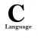
What is Function in C Language?
by rajkishor09
- 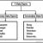
Data Types in C Language
by rajkishor09
Array in C programming – Programmer's view
by rajkishor09
- 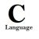
How to work with Multidimensional Array in C Programming
by rajkishor09
Pointers in C Programming
by rajkishor09
- 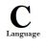
C Programming – Structure at Work
by rajkishor09
COMPUTER SCIENCE AND PROGRAMMING FORUM
Topic | Replies
ASP is better or PHP?posted by PMS9 | 4
Best CMS 2010posted by byinternet | 4
'Space pioneers' of the commercial era (images)posted by aamirshahji | 0
post a new topic
TAGS
- computer programming
- c programming
- programming languages
- learn programming
- integer
- learn computer programming
- programming help
- return statement
- function arguments
- return value
- computer programming language
- c programming help
- software email database
- help c programming
- back calling function
- declared integer
- sends two integer
- integer value
- data calling function
- type function
- called function calling
- functions arguments return value
- function return type
- back data calling function
- declare function
- function argument
- user defined function
- called function
- function control
- calling function
- functions arguments return values
- return multiple values
- functions arguments return
- going explain
- code explanation
- arguments return
- return values
- arguments return values
- integer variable
- control output
- programming software
- udf
- functions arguments
- sends back
RECOMMENDATIONS
HubPages
- about us
- learning center
- blog
- affiliates
- advertise
- link to this page
- copyright
Copyright © 2010 Hubpages Inc. and respective owners. All rights reserved.
Other product and company names shown may be trademarks of their respective owners.
terms of use privacy policy (served in 0.231 sec)

